**Level 1: PC Tower Case**

**Outline**

Learn about the internals of a standard PC case by examining physical samples and selecting and labeling images found on-line. Gain deeper knowledge by researching and reporting on specific components.

**Questions**

1. Find one (or more) images that clearly show the internals of a PC Tower Case.   
   (i.e. Google images using keywords “PC Case Internals”)

<https://www.google.com/url?sa=i&source=images&cd=&ved=2ahUKEwjx3_G2ubngAhWGw4MKHVjqBmYQjRx6BAgBEAU&url=https%3A%2F%2Fwww.pcworld.com%2Farticle%2F255764%2Fhow_to_build_an_energy_efficient_and_quiet_gaming_pc.html&psig=AOvVaw3YIA-EkO3O3BWnEUjgBEWS&ust=1550172569952957>

Cooling Fan

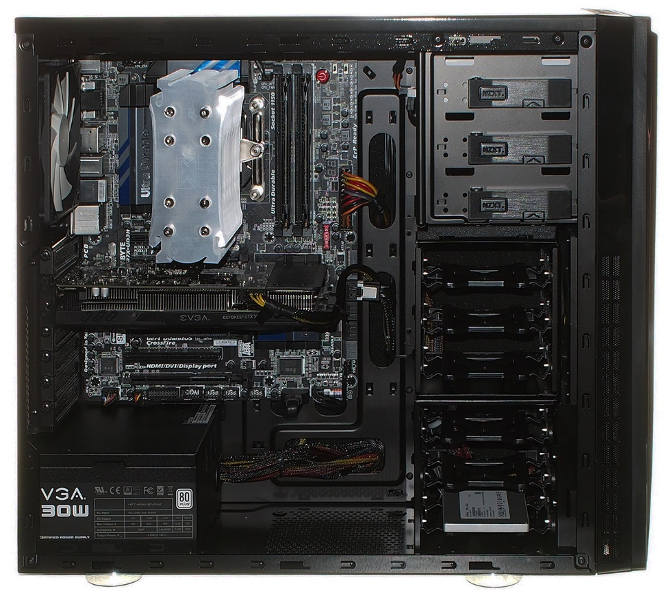

Motherboard

Hard Disk Drive

Power Supply

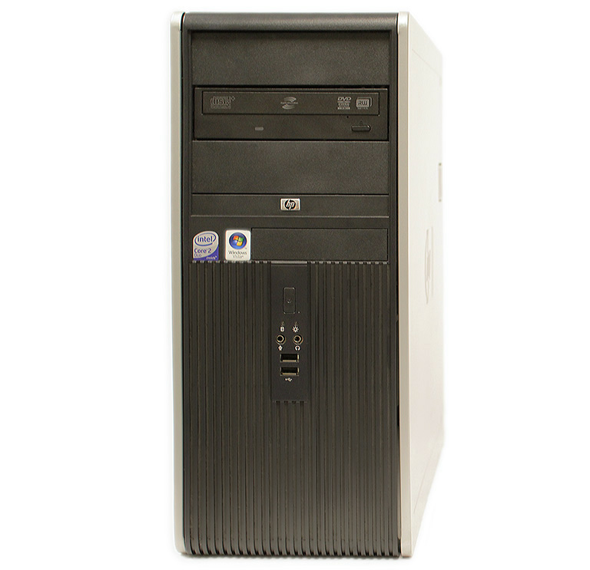

USB Expansion Ports

Optical Disk Drive

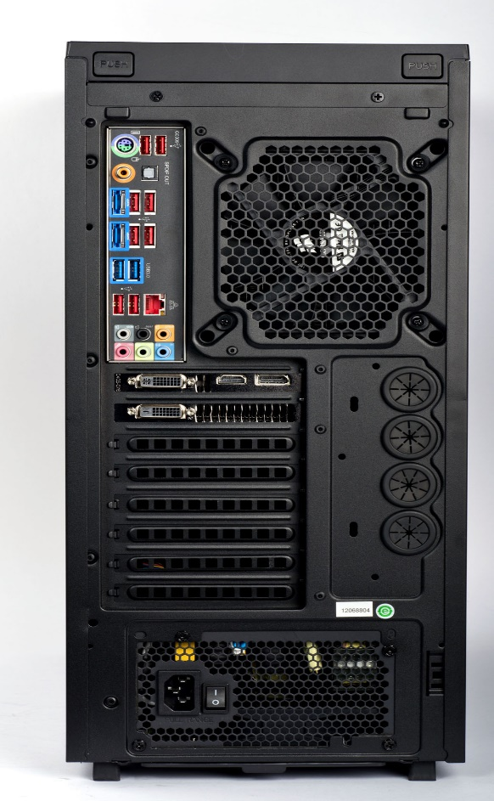

Cooling Fan

Ethernet Port

Audio Ports

Monitor Ports

1. Clearly label the following components (using arrows) on your image of the PC case internals:
   1. Motherboard
   2. Power Supply
   3. Hard Disk Drive
   4. Optical Disk Drive (e.g.DVD)
   5. USB Expansion Ports
   6. Monitor Port
   7. Audio Ports
   8. Ethernet Port
   9. Cooling Fan
2. Research more in-depth about “Motherboards”. Make notes on the following:
   1. What different versions are currently available (speed and capacity)

The different versions that had been available and currently available are the AT motherboard has speed of around 100 MHz and a capacity of 16 GB. The ATX motherboard has speed of around 200 MHz and a capacity of around 32 GB. Some other examples are the LPX, the BTX, the Pico BTX, and the Mini ITX motherboard. I will now explain information about the general motherboard. There are different “buses” that connect parts of the motherboard and allow information and data to travel. The speed of the bus which is just how must data can move across the bus is measured in megahertz (MHz). The amount of data that can move across the front side bus can range from 66 MHz to 800 MHz. The speed of the back-side bus is determined by the processor. The speed of the accelerated graphics port bus is usually 66 MHz.

* 1. How the component has changed since the 1980’s

Originally, the motherboard had very minimal integrated devices and other main components were connected through expansion slots. Overtime though, more components were integrated into the motherboard which resulted in higher speed devices and faster buses. The downside of this initially was that it was difficult to remove certain integrated part on the motherboard. This has been improved over time. Motherboards have been made smaller and more powerful so this results in faster speeds and increased capacity.

1. Research more in-depth about “Hard Disk Drives”. Make notes on the following:
   1. What different versions are currently available (speed and capacity)

The different versions that are currently available are the PATA, SATA, SCSI, and SSD. The PATA drive has speeds of 133 MBs/second and a capacity of 137 GB. The SATA drive has speeds of 600 MBs/second and a capacity that can range from 500 GB to 8 TB. The SCSI drive has speeds of 640 MBs/second and a capacity that can range from 147 GB to 320 GB. The SSD drive has speed from 654 MBs/second to 712 MBs/second and a capacity ranging from 1 TB to 4 TB.

* 1. How the component has changed since the 1980’s

Throughout the 1980s and onwards, hard drive makers have developed hard disk drives that are smaller than before. The sizes of the hard disk drive was being reduced in inches! There was an increasing need for better, faster, more reliable and smaller hard disk drives which resulted in the creation of drives such as the SATA and SCSI drives. The hard disk drives are being improved in terms of their speed and capacity at a rapid speed.

**NOTE:**

* Download the on-line version of this module (from the class GitHub repository)
* Questions for Level 2 and Level 3 are in the on-line version of this module
* Provide your answers in a MS Word, PowerPoint, or equivalent format
* Upload your answers to your personal GitHub repository

**Level 2: PC Motherboard**

**Outline**

Learn about the structure of a standard PC motherboard by examining physical samples and selecting and labeling images found on-line. Gain deeper knowledge by researching and reporting on specific components.

**Questions**

1. Find one (or more) images that clearly show the layout of a PC Motherboard.   
   (i.e. Google images using keywords “PC Motherboard”)

Hard Disk Drive

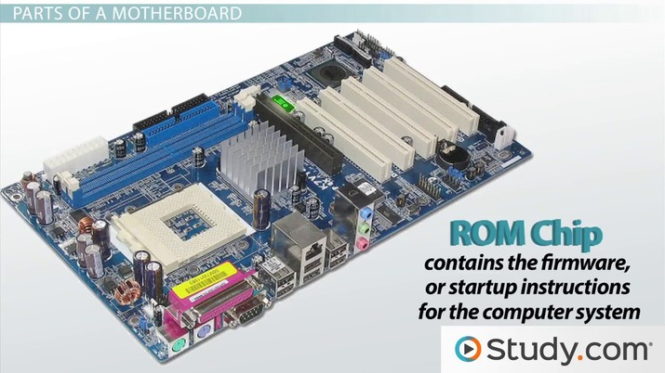

Sound Processor on Sound Card

Ethernet Ports

GPU

RAM Memory Slot

Fan Mounting Points

CPU Socket

1. Clearly label the following components (using arrows) on your image of the PC motherboard:
   1. CPU (and fan)
   2. RAM Memory
   3. Disk Drive Interface (IDE or SATA)
   4. GPU Graphics Processor (either on-board or Graphics Card)
   5. Sound Processor (either on-board or Sound Card)
   6. Wi-Fi / Ethernet Network Interface (either on-board or Graphics Card)

1. Research more in-depth about “CPU Processor Chip”. Make notes on the following:
   1. What different versions are currently available (speed and capacity)

There are 2 main manufacturers of CPUs which are Intel and AMD and they lead the market in terms of speed and quality. The main CPUs for Intel are Celeron, Pentium, and the i9. The Celeron speed can range from 1.6 GHz to 2.44 GHz while the capacity depends on the motherboard. The speed of the Pentium is 3.5 GHz while the capacity depends on the motherboard. The speed of the i9 can range from 3.6 GHz to 5 GHz while the capacity depends on the motherboard. The main CPUs for AMD are Sempron, Athlon, and Phenom. The speed of the Sempron can range from 1.0 GHz to 2.9 GHz while the capacity depends on the motherboard. The speed of the Athlon can range from 2.2 GHz to 2.4 GHz while the capacity depends on the motherboard. The speed of the Phenom can range from 1.8 GHz to 2.6 GHz while the capacity depends on the motherboard.

* 1. How the component has changed since the 1980’s

These complex units are considered the brain of the computer and they are constantly being improved. Overtime, engineers are able to cram more of these transistors in CPUs in the same amount of space. There was and still is a huge demand for making CPUs that are faster, smaller, heat up less, and more affordable to the public. The problem with old CPUs was that they were really big, not powerful, heated up very quickly and most of the public couldn’t afford it. Now, they are many different companies that are competing to take the lead in this ever-growing market.

1. Research more in-depth about “RAM Memory”. Make notes on the following:
   1. What different versions are currently available (speed and capacity)

The different versions that are currently available are Static RAM (SRAM), Dynamic RAM (DRAM), Synchronous Dynamic RAM (SDRAM), Single Data Rate Synchronous Dynamic RAM (SDR SDRAM) and Double Data Rate Synchronous Dynamic RAM (DDR SDRAM). The system memory for SRAM is around 20-40ns while the capacity can vary. The system memory for DRAM is around 80-100ns while the capacity can vary. The speed of the SDRAM can range from 100 MHz to 166 MHz while the capacity can vary. The speed of the SDR SDRAM is around 133 MHz to 200 MHz while the capacity can vary. The speed of the DDR SDRAM is around 133 MHz to 200 MHz while the capacity can vary.

* 1. How the component has changed since the 1980’s

Initially, RAM was very slow and it took very long to access files. The different versions used to be very large and slow. But the demand for products that were faster, smaller and cheaper resulted in the creation of different RAM. These were faster and had a lot more capacity while having smaller sizes and being more compatible. RAMs took a lot of space but now that it has evolved, the sizes of the versions of RAMs have decreased in centimeters.

**Level 3: Peripheral Devices**

**Outline**

Learn about how peripheral devices are connected to the back side of a typical PC tower case. Examine physical samples, select and labeling images found on-line and gain deeper knowledge by researching and reporting on specific components.

**Questions**

1. Find one (or more) images that clearly show the layout of the back of a typical PC tower case.   
   (i.e. Google images using keywords “Back Of PC Tower”)

Mouse and Keyboard Interface



Ethernet Interface

Audio Inputs/Outputs

USB Ports

Monitor Interface VGA

Power Cord and Power Switch

1. Clearly label the following components (using arrows) on your image of the back of a typical PC tower case:
   1. Power cord and power switch
   2. Monitor Interface (VGA or DVI or HDMI)
   3. Mouse Interface (USB or PS/2)
   4. Keyboard Interface (USB or PS/2)
   5. USB Ports
   6. Audio Inputs / Outputs
   7. Ethernet Interface

1. Research more in-depth about “Monitor Technology”. Make notes on the following:
   1. What different versions are currently available (e.g. VGA / DVI, Flat Panel Technology))

The main types of monitors are CRT monitors, LCD monitors, and LED monitors. CRT monitors used to be commonly used but are not being used often now due to better monitors such as LCD and LED. CRT monitors have an intense stream of electron to form images on the fluorescent screen. But these are heavy, cost a lot, and take up a lot of energy. A VGA connected to this CRT monitor can produce resolutions up to 2048x1536. LCD and LED monitors are usually Flat Panel Technology because they are thinner, lighter and more portable. This means they use thin panel design instead of the old CRT design.

* 1. How the component has changed since the 1980’s (e.g. Display Resolution, Technology)

The old CRT monitors used to be bulky and dull coloured. Due to increasing consumer demand for more and for less cost, companies continue to improve their technologies and improve the experience of the consumers. There are now monitors with 4k quality and curving displays. Old monitors and TVs used to be very large in-order to accommodate the cathode ray tubes in CRT. LCD monitors were then developed and they didn’t need to be as big as CRT monitors. They also created sharper images and used less energy. But they were very expensive and not affordable by everyone. Now, there are even more types of monitors and TVs such as LED, QLED, OLED by different companies. They are now sharper, smaller in width and bigger in display, and they cost less.

1. Research more in-depth about “External Portable Storage”. Make notes on the following:
   1. Floppy Disks

A Floppy Disk is a soft magnetic disk used for storage. It was called floppy because we could wave it. They were made up of thin magnetic storage material. Floppy disks have limited uses and their capacity is not that much. They were first available in the 1960s and 1970s and they were one the ways to store data.

* 1. CD-ROM / DVD / Recordable CD/DVD

A CD-ROM is a CD that can be read using an optical drive. The data in the disk is read only and this means that is cannot be altered or erased. Due to this feature and their large capacities, they were great for media format. They are used today and can store different kinds of data.

* 1. USB Memory Drives

Also known as USB Flash Drive, it is a data storage device that includes flash memory with USB interface. It is lightweight, easily transportable, high storage capacity with a low price. USB Memory Drives were first introduced in the early 2000s are still in use today.

* 1. Compact Flash Memory

Compact flash memory is a mass storage device used in mainly portable electronic devices. It is one the first and most successful memory cards. They are very small, lightweight, transportable, and have huge storage capacities. They are used in cameras with companies such as Canon and Nikon.

* 1. Cloud Based Storage

It is a model of computer data storage but where digital data is stored and can be shared. There are cloud storage providers and this makes the data available and accessible and it is safe. Cloud based storage could be used to store user, organization or application data.

**Level 4: PC Component Presentation**

**Outline**

Explore the development and features of a specific PC hardware component through deeper research and investigation. Work in partners to create a short presentation. Deliver the presentation to the class.

Each group will research a unique PC hardware component . Your specific topic will be assigned from the list provided below.

**Presentation Structure**

1. Explain what the PC component does and how it fits together with other components to make up a fully functioning PC.
2. Explain how the PC component works. Provide a diagram (image) showing the main parts of the component.
3. Research the current state of the art of the component in terms speed, capacity (size), and other related factors.
4. Research on-line suppliers that sell the PC Component. List the specifications for the available products and the cost (price).
5. Research how the PC component has changed and evolved since the early days of PCs in the 1980’s. Cover each of the following topics separately:
   1. Component Speed
   2. Component Size / Capacity
   3. Two other specifications specific to the PC component (ask Mr. Nestor)

**PC Component Topics**

|  |  |  |
| --- | --- | --- |
| **Topic** | **Partner 1** | **Partner 2** |
| CPU Microprocessor Chip |  |  |
| Motherboard Layout |  |  |
| Computer Graphics |  |  |
| Sound & Audio |  |  |
| Hard Disk Drives |  |  |
| Removable Disk Storage |  |  |
| Network / Internet Connectivity |  |  |
| Mouse / Pointing Devices |  |  |
| Monitor & Display Technology |  |  |
| Printers & Output Technology |  |  |